27 Discover_Two Tables with Comparison and Ranking
Report Views
Standard View
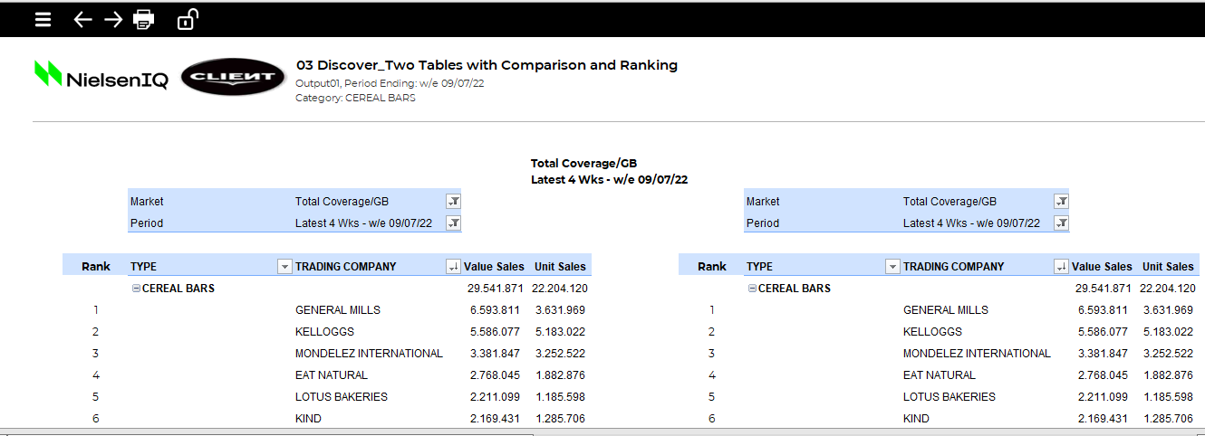

Standard View
Guidelines
Template Name | 27 Discover_Two Tables with Comparison and Ranking
View Name | Standard View
Methodology | Pivot Table
Default Dimension Order for Pivot Table | Filters | 2 Dimension | Markets, Periods
Default Dimension Order for Pivot Table | Columns | 1 Dimensions | Facts
Default Dimension Order for Pivot Table | Rows | 1 Dimension | Products
Change dimension | - The dimensions can be swapped (in Developer Mode)  - Any dimension to be kept in Filters must be available in Rows in the Discover source input table  - Both pivot tables should use the same source to make it meaningful.  - The Rank column is not a part of the pivot table.  - The sorting is done on the product dimension in the pivot table and is based on the fact Umsatz. It can be changed/removed based on the requirement.  - The “*_Flag” field is to be used for sorting of a dimension, preferably Periods (trended). To do the same, please drag the “*_Flag” field to the area  (e.g. - Columns) for the Pivot table above the field (e.g. - Periods) to be sorted. Then filter out the flag column using AZ column to exclude it from the pivot table view.  *_Flag concept: If the first dimension in rows is Periods, then the label will be Periods_Flag. If it is facts, then the label will be Facts_Flag, and so on.
Data Selection Guidelines | Facts | - No limitation in number  - Can be renamed/re-labelled as per requirements  - Can be nested under another dimension (e.g. - Periods) in Pivot Table  - Multiple item/All selection in Filters is NOT recommended, as it will return erroneous aggregated values
Data Selection Guidelines | Products | - No limitation in number  - Can be renamed/re-labelled as per requirements  - Product selection starts with the Total product line followed by the products for the report
Data Selection Guidelines | Markets | - No limitation in number  - Can be nested under another dimension (e.g. - Periods) in the “Columns” area in Pivot Table
Data Selection Guidelines | Periods | - No limitation in number
Data Selection Guidelines | IMPORTANT:  - Pivot Fields will be locked in the auto-open mode and any changes in the same are to be done in the developer mode only.  - Poor performance can be observed mostly in reports with multiple Output Sheets.  - If any rows/columns are to be deleted, ensure you do not remove any important part of report configuration area.  - Multiple/All selections in filters is discouraged to avoid illogical aggregation (E.g. - Aggregation of different/unrelated facts/markets/periods/products).  - +/- Buttons are not to be turned on for Pivot Tables, as the same might result in incorrect aggregation of data in the table (E.g. – incorrect aggregation of individual % share lines by pivot, resulting in total % share values>100%)
To create a new report from this template | - Welcome Sheet – Check if the Configuration Area are filled in by the correct information.  - Output Sheet – Insert all the needed information on the first Row in the Parallel of the Table, if you add more Columns.  - Drag required fields/dimensions into respective areas for Pivot Table (follow Data Selection Guidelines above)  - Depending on the number of periods, the table formatting and Charts will have to be adjusted.  - To make formatting easier, the existing formats can be copied  - The default template uses two items for the dimension in column. If more items are present, the second pivot and the ranking column needs to be moved to make space for extra columns in the first pivot table.

